APPENDIX 1 – Site Block Plan

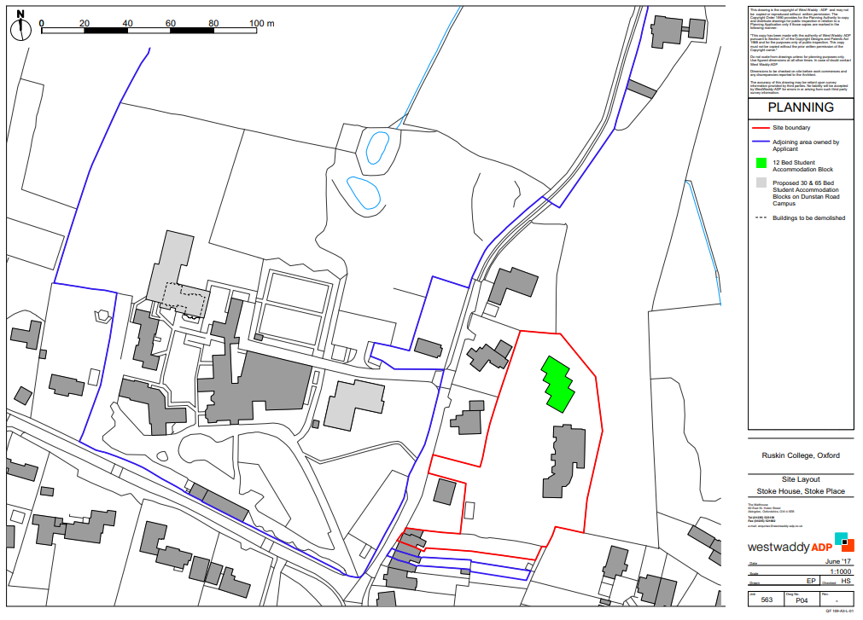
Ruskin Hall
Campus
New 12 bed block
Stoke House
Campus

